Creating new user as dbms_mp and granting all privileges to dbms_mp.

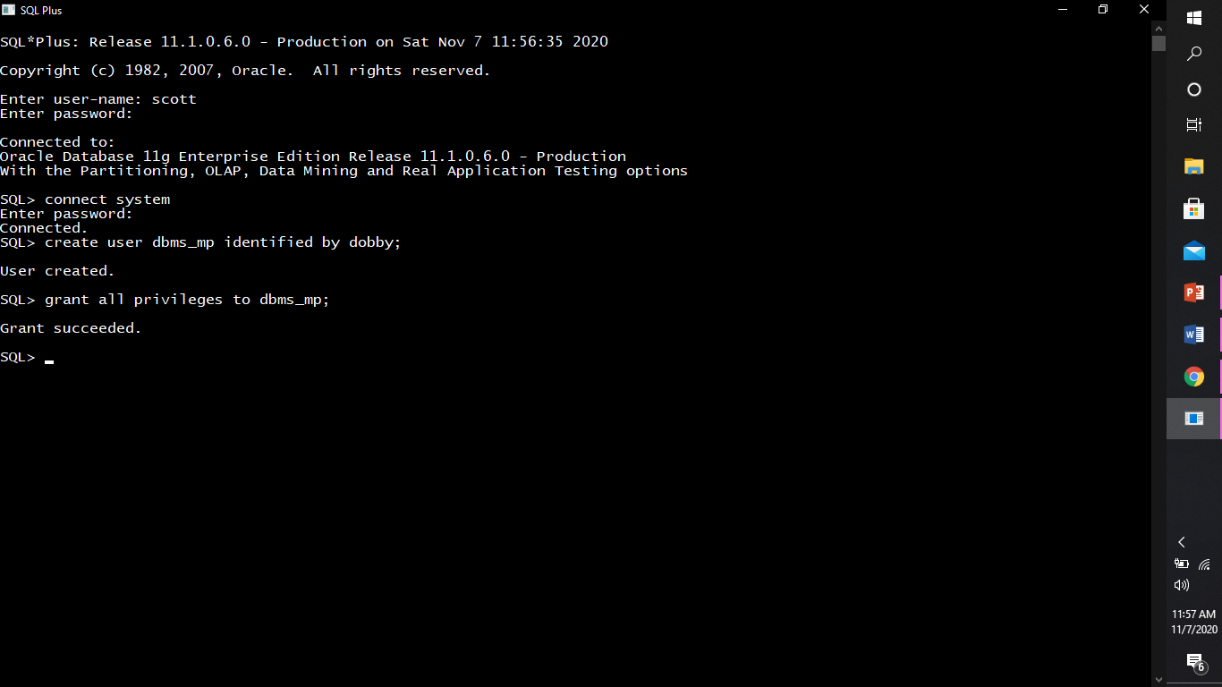

Connecting to dbms_mp.

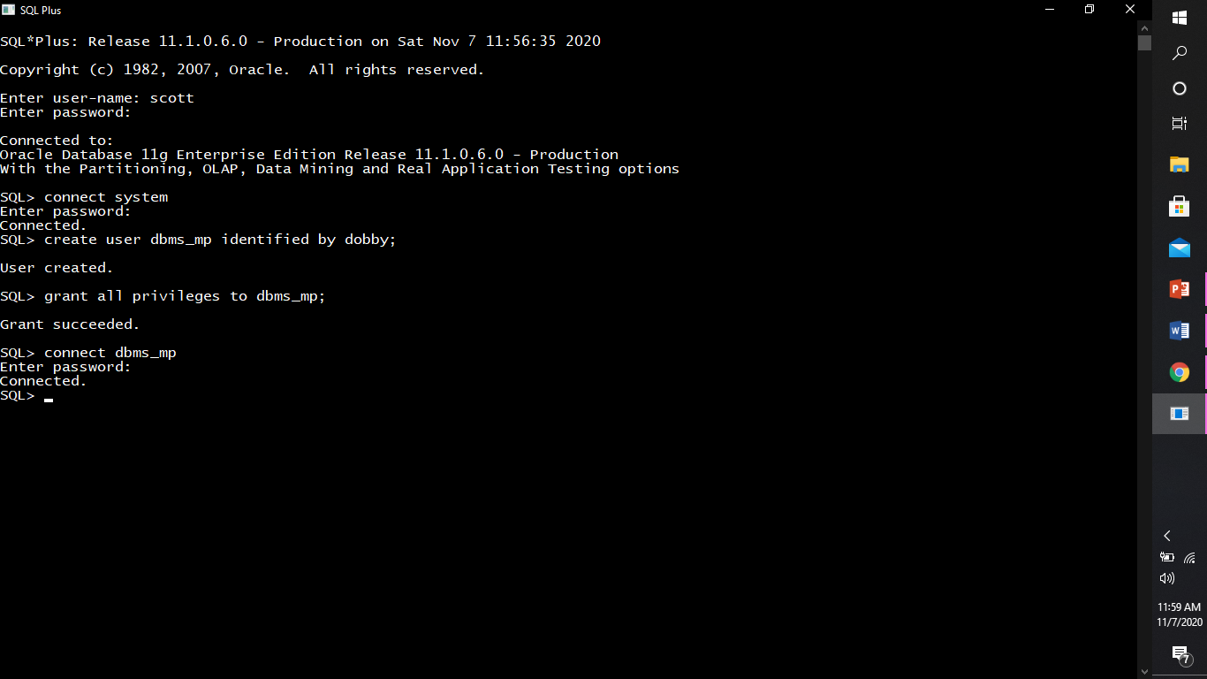

Creating table world.

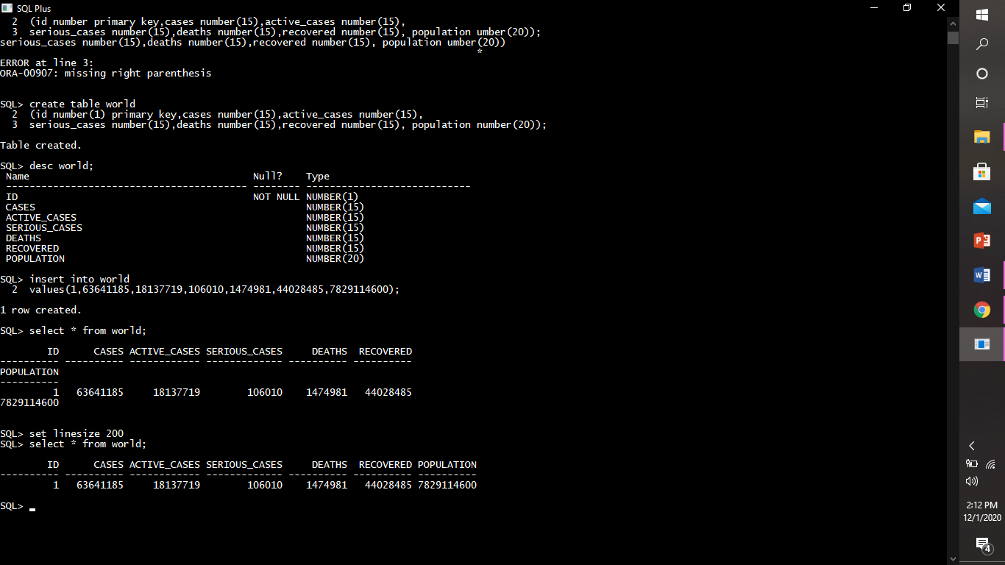

Describing structure of world table.



Inserting rows into world table.





Creating table country_id.

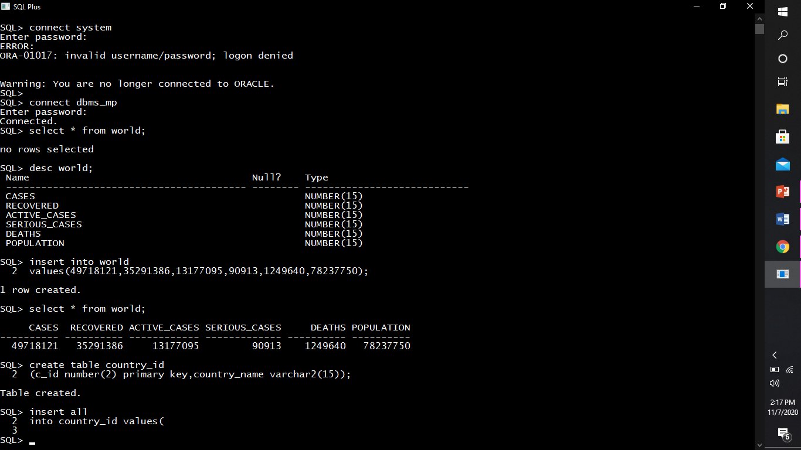

Describing structure of country_id.

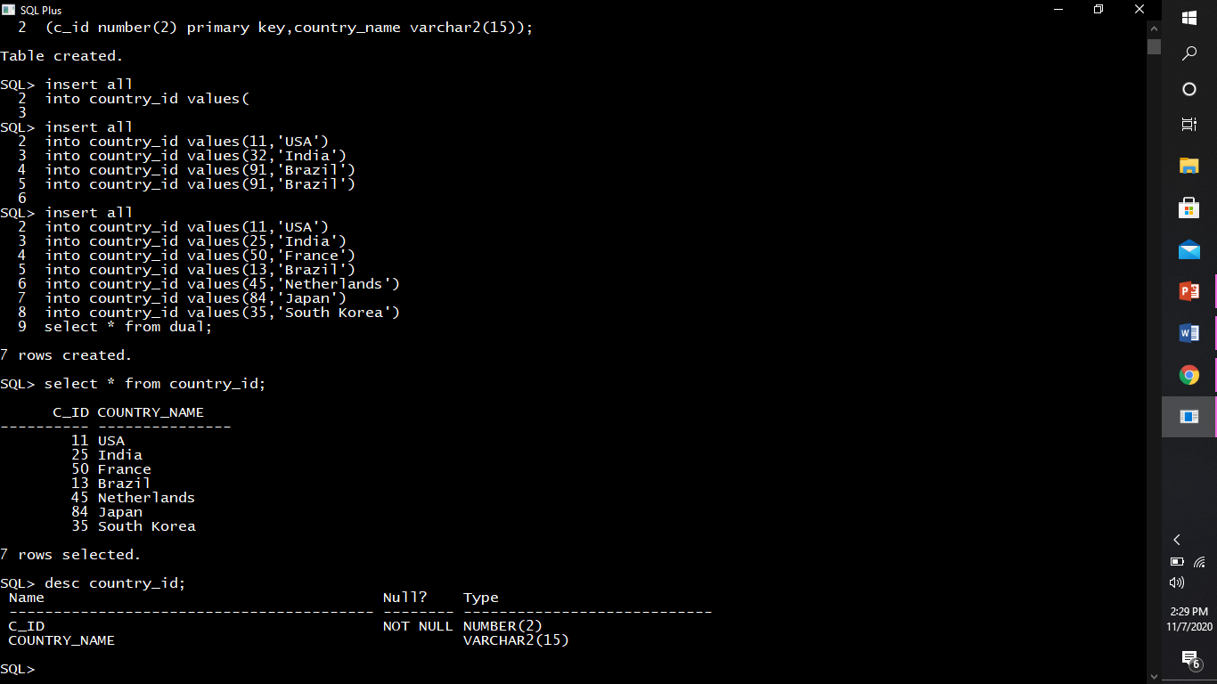

Inserting rows into country_id table.

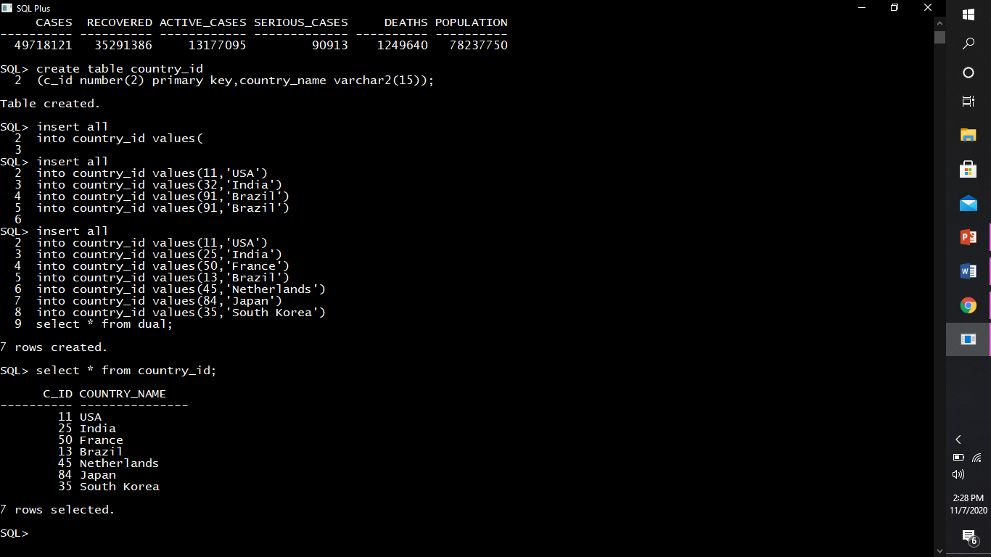

Creating table countries.

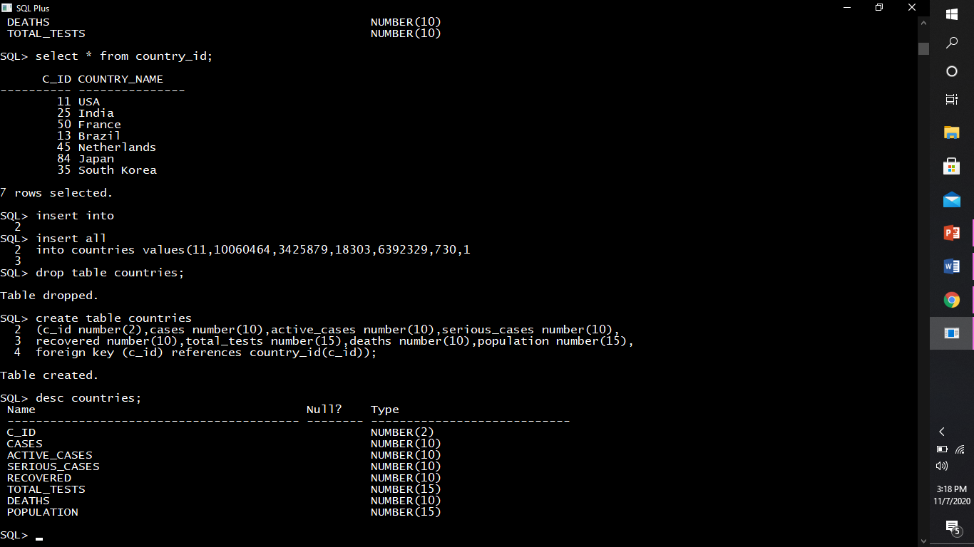

Describing structure of countries.



Inserting rows into countries table.

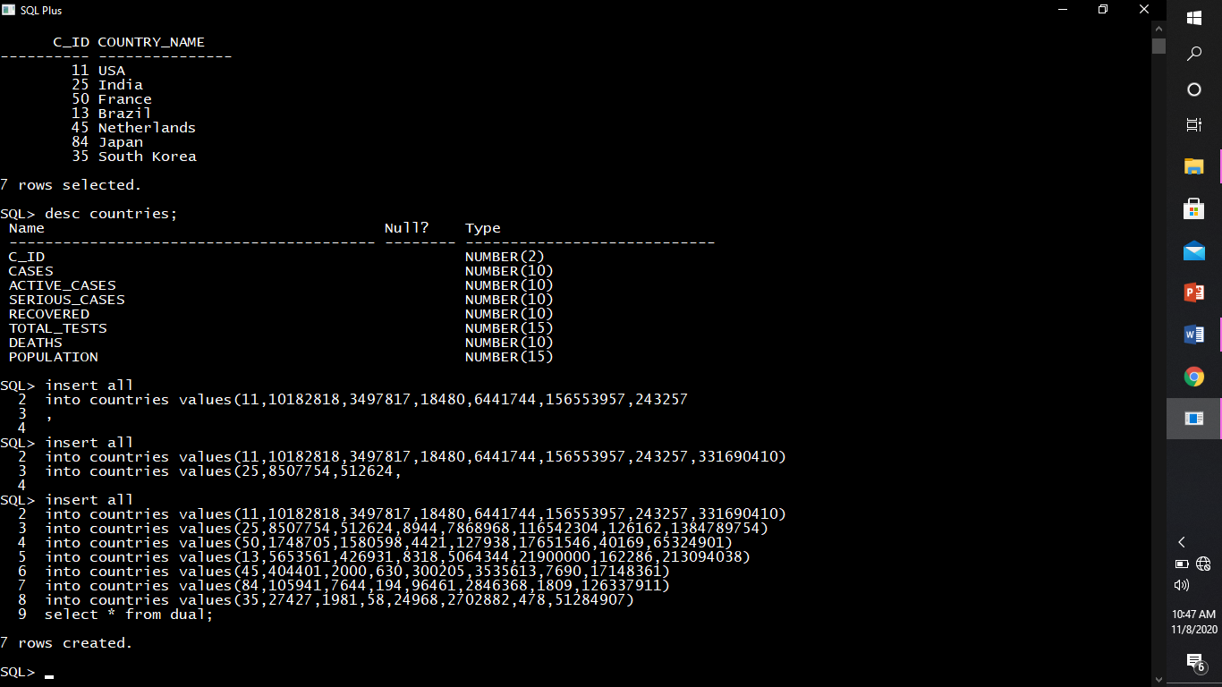

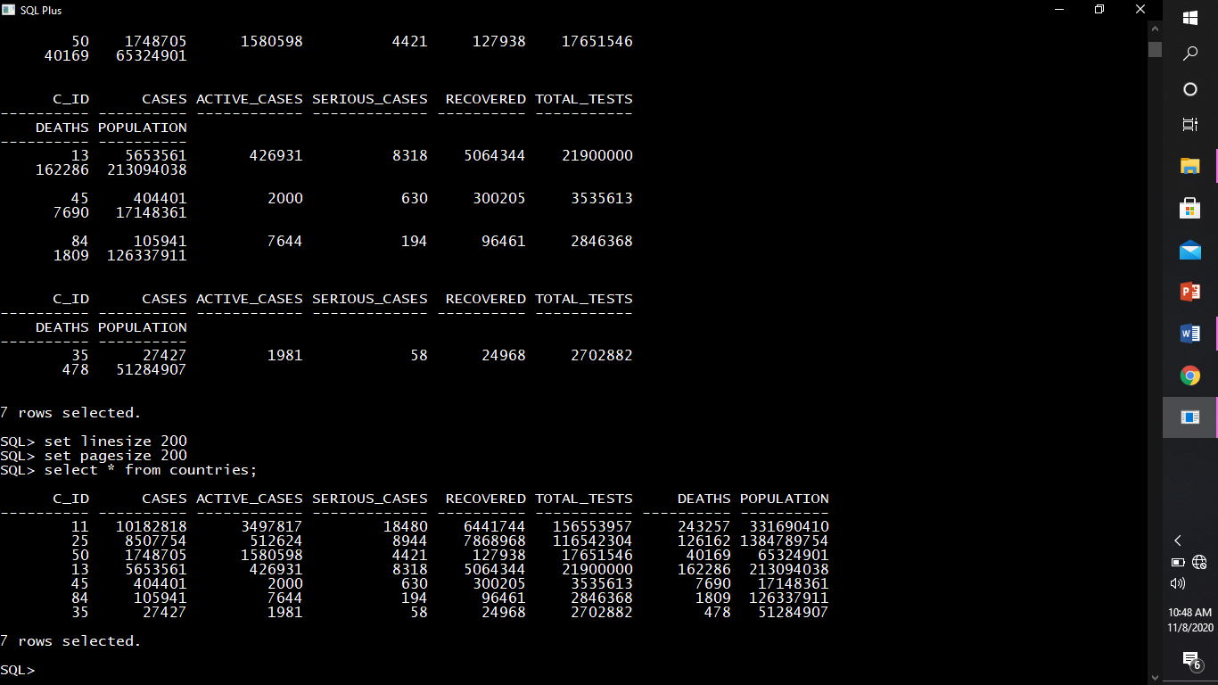

Creating table vaccine_creation_info

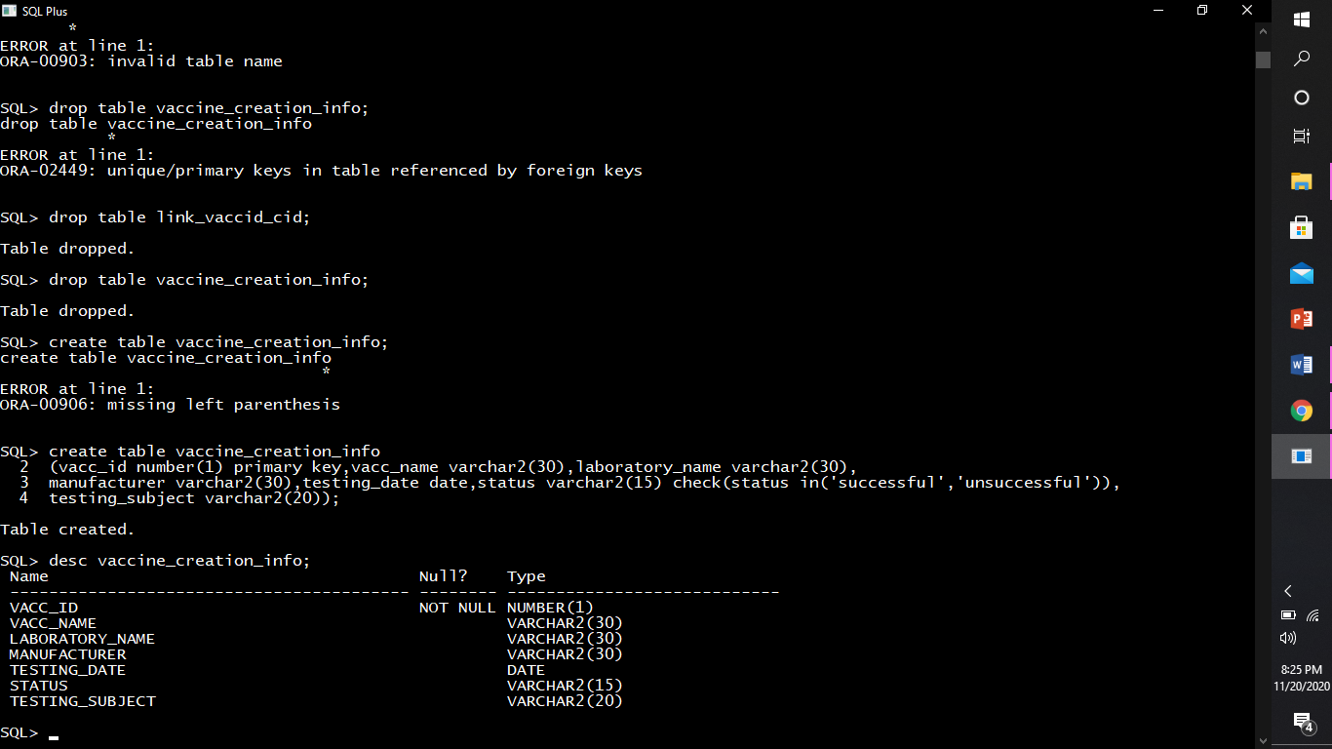

Describing structure of vaccine_creation_info



Inserting rows into vaccine_creation_info

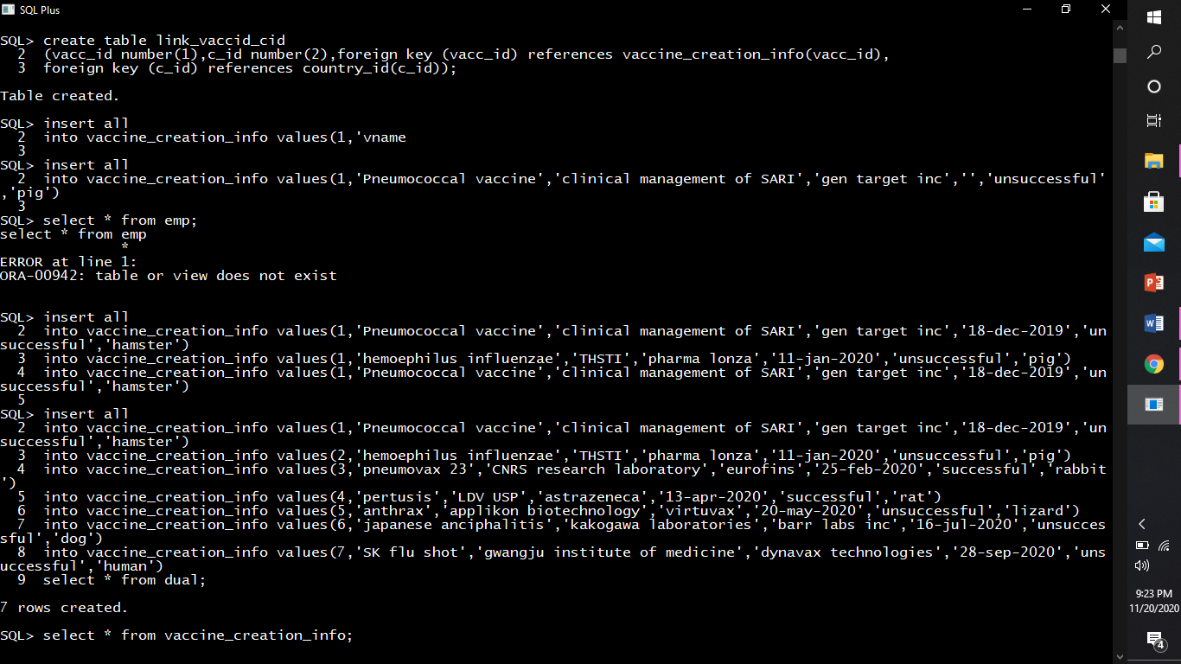

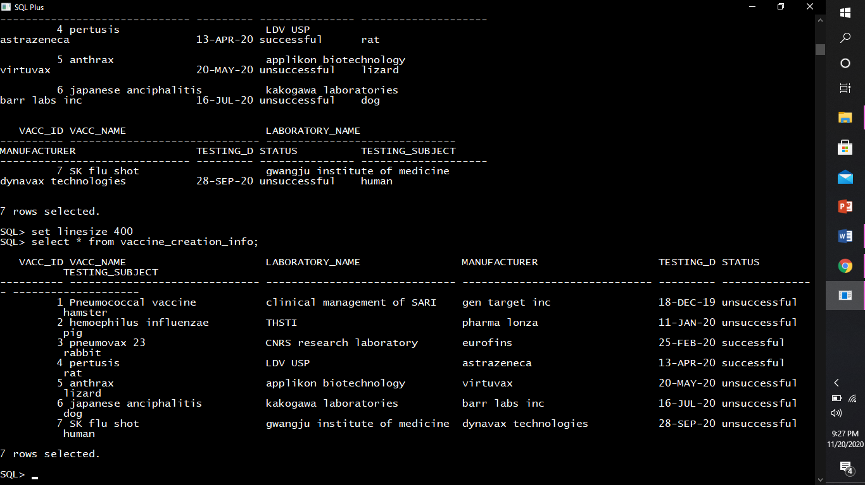

Create table link_vaccid_cid

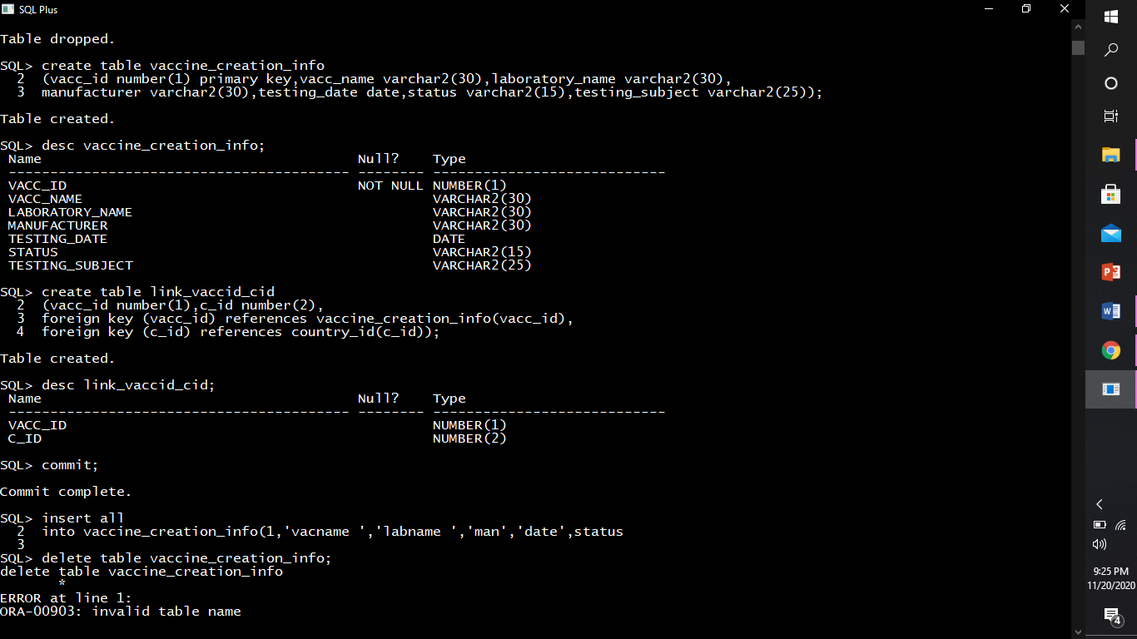

Describing structure of link_vaccid_cid

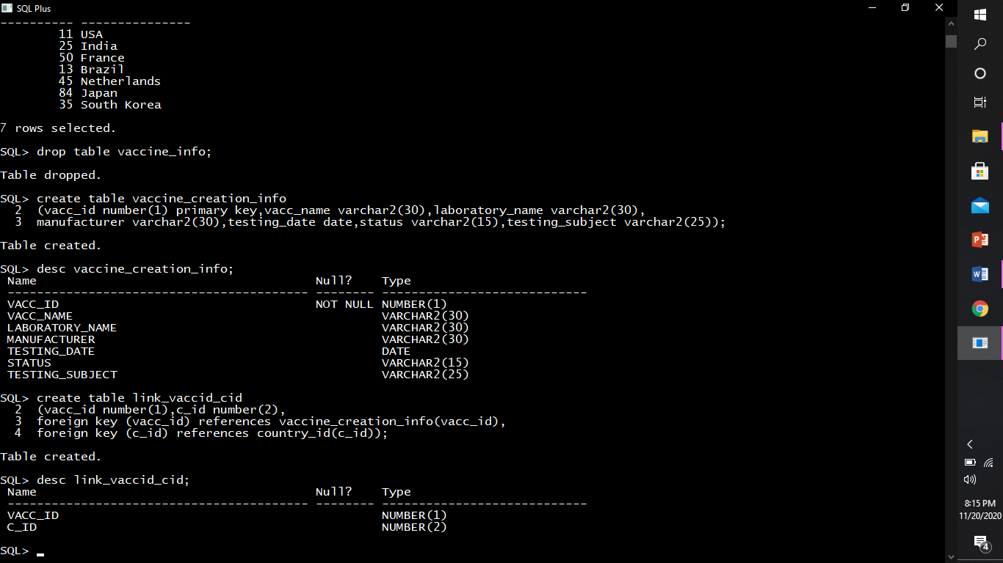

Inserting rows into link_vaccid_cid

